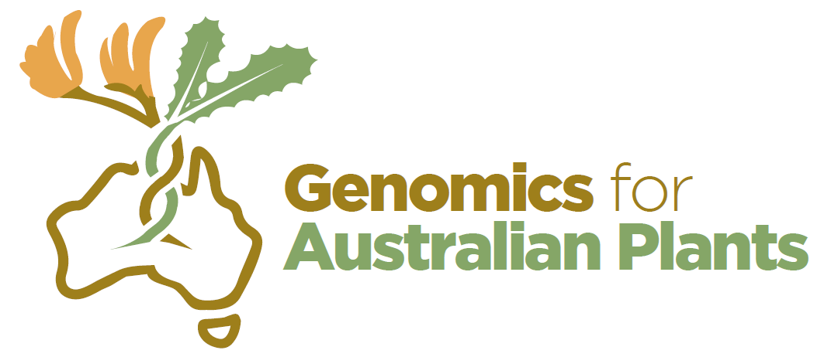
Genomics for Australian Plants
Conservation Genomics EOI

Background
Australia has over 21,000 species of flowering plants, many of which are under threat. The Genomics for Australian Plants (GAP) Initiative was catalysed by Bioplatforms Australia in partnership with researchers from the Australian State and National Herbaria and Botanic Gardens. Bioplatforms investment in genomics data generation is augmented with in-kind contributions from the wider plant community in sourcing plant material, preparation of material for genomic sequencing, development of bioinformatics pipelines for data analysis and data sharing. This includes contributing to and benefiting from collaborations with other international initiatives. The three main aims of the initiative are the generation, analysis and dissemination of genomics data in the following areas: Reference genomes, Phylogenomics and Conservation genomics.

The Conservation Genomics component aims to provide genomic information to support conservation of the Australian flora against a background of threats. Conservation genomics covers a range of activities according to the management questions being addressed. Studies that aim to resolve species complexes have been prioritised by the GAP Steering Committee as they address the principles developed for the GAP initiative i.e.: uses herbarium specimens; builds capacity in herbaria and botanic gardens; provides genomic resources that can be used in future studies; improves knowledge of Australian plant diversity; has a direct conservation benefit and can be implemented across Australia with a common approach.

The Steering Committee is calling for Expressions of Interest for Conservation Genomics projects that will lead to resolution of a species complex using genomics and meet the following criteria:
- The species complex is expected to include species of conservation concern, where genomics data are required to inform taxonomic resolution.
- Taxonomic expertise is available to utilise the genomic information.
- Genomics capability is available to provide genomics expertise in data analysis and interpretation (the Steering Committee may be able to identify relevant genomics expertise from within the Consortium for submissions from taxonomists).
- Samples are available either as Herbarium specimens or fresh/dried material (with appropriate herbarium vouchers) and resources are available to obtain samples for sequencing.

It is anticipated that proposed projects acquire the genomics information required to inform resolution of entities using the ddRAD approach available through Bioplatforms facilities. Subsequently, projects would be expected to follow this by analysis of representatives from key taxa with a bait capture approach recommended by the Phylogenomics component of GAP, to ensure longer term interoperability of the data. At this stage projects will undertake the ddRAD analysis only, and the bait capture will be undertaken at a later date.

Collaborators will be required to agree and to sign the GAP Collaboration Agreement (which includes the Data and Communications Policies), which have been developed to ensure that both research teams and the research community benefit from data generated by the GAP initiative. As a general principle, attributable data will be made available in the public domain within 12 months of sequence generation.

Collaborators will be required to undertake the following activities using their own resources:
- Project design
- Sample preparation and supply of metadata
- DNA extraction from samples
- Data analysis
- Publication

Bioplatforms will provide the following resources:
- Library preparation and sequencing
- Project management and data management (raw data storage and access, with associated metadata)

Projects may submit samples in batches of 47 samples (half plate), 95 samples (1 plate), 143 samples (1.5 plates) or 191 samples (2 plates). The Project Manager, Mabel Lum mlum@bioplatforms.com can provide further information on ddRAD sample quality requirements.

Genomics for Australian Plants FAQ

- How can I get involved?
All Consortium members are required to agree and sign the GAP Collaborative Agreement.

GAP Agreements and Policies can be found here:
https://www.genomicsforaustralianplants.com/agreements-policies/

GAP webpage:
https://www.genomicsforaustralianplants.com/

GAP Data Portal:
https://data.bioplatforms.com/organization/about/bpa-plants
Note: Access to GAP data is restricted to Consortium members for period of 12 months.

Please see the Data Policy for more details:
https://www.genomicsforaustralianplants.com/agreements-policies/

- How is the GAP project funded? How long is the GAP project funded?
GAP is funded by Bioplatforms through the Australian Government National Collaborative Research Infrastructure Strategy (NCRIS), with additional contributions from the Botanic Gardens and Herbaria.

Bioplatforms funding for the project is for 3 years, from December 2018.

The Ian Potter Foundation has also provided substantial funds for 5 years (bioinformatics position, bioinformatics training and some funds for wet lab).

- What are Bioplatforms’ investments in GAP?
Bioplatforms investment is in genomics data generation, raw data storage and project management.

- What in-kind contributions are expected of the researchers?
In-kind contributions from the wider plant community include sourcing plant material, preparation of material for genomic sequencing (e.g. DNA extractions), development of bioinformatics pipelines for data analysis and data sharing (e.g. contributing to and benefiting from collaborations with other international initiatives).

- Can I apply for funding from GAP for my own research?
GAP is a nationally-inclusive and collaborative initiative. We do not fund individual research projects. The aim of the initiative is to build resources which will benefit the plant community.

- What is the GAP Data Policy? Who can access data from my samples if I am part of GAP?
Data access falls broadly into two phases: a “mediated-access” phase, where access to the data will be limited to members of the Consortium and other authorised parties; and an “open-access” phase where the data will be made openly available from resources including International Data Repositories.

Consortium members who have agreed and signed the GAP Collaborative Agreement will be given access upon registration at the Data Portal.

The “open-access” phase is set at 12 months from deposition of data into Bioplatforms Data Portal to allow the members of the Consortium and other authorised parties to progress analysis and publications, but not hold up the release of the data to be made openly available from resources including International Data Repositories.

GAP Data Portal:
https://data.bioplatforms.com/organization/about/bpa-plants

GAP Agreements and Policies can be found here:
https://www.genomicsforaustralianplants.com/agreements-policies/

- Will I be acknowledged if other Consortium members use data from my samples in their publication?
All communications (scientific or general publications and presentations) that arise from the Consortium’s work will appropriately acknowledge the input of all relevant contributions.

The publications should specify the collaborative nature of the project, and authorship is expected to include all those contributing significantly to the work.

Authorship for publications will be determined on a case-by-case basis.

For more details, please see the GAP Agreements and Policies:
https://www.genomicsforaustralianplants.com/agreements-policies/

Genomics for Australian Plants
Conservation Genomics EOI

Instructions for filling in this document:
- Fill in your details in the table below.
- Complete one document for each species complex.
- Address all the criteria listed.
- Provide a short 1 paragraph answer for each question.
- Answers to all the criteria should not exceed 3 pages.
- Please note: All samples submitted to the GAP project needs to have accompanying metadata. Sample without metadata will not be accepted.

Deadline: COB Monday, 6th July 2020
Please email your completed documents to Mabel Lum mlum@bioplatforms.com

Contact information:
Margaret Byrne | GAP Conservation Genomics lead | T +61 8 9219 9943 | margaret.byrne@dbca.wa.gov.au
Mabel Lum | Project Manager | T: +61 435 387 007 | mlum@bioplatforms.com

Please fill in your details below:
Project coordinator:
Affiliation:
Contact details: | Email:  Phone:
Species complex:
Collaborators in the project:

List of criteria to be addressed:
2. Detail the taxonomic expertise available to support the project.

3. Detail the genomics expertise available to support the project (GAP may be able to assist in sourcing genomics expertise if required).

1. Describe the current knowledge of the species complex, and information on conservation issues within the group.

List of criteria to be addressed:
5. Describe the Project Plan, including sampling design, sequencing approach, bioinformatics analysis and anticipated taxonomic outcomes

Sampling design:

Sequencing approach:

Bioinformatics analysis:

Taxonomic outcomes:

4. Identify the samples available to undertake the project.
Are the samples available now?
If not, when will they be available?

List of criteria to be addressed:
8. Provide details of sample storage and curation, including arrangements for Herbarium vouchers.

7. Provide details of end user engagement and anticipated conservation outcomes.

6. Provide any other information on the species complex, e.g. life form, genome size, ploidy, ease of DNA extraction etc.

